**PORTFOLIO**

**COMPUTER SCIENCE AND ENGINEERING**

Submitted by:

Name: Prince Kumar

Registration number: 12323420

Roll No.: 01

Section: K23PT

**Submitted to :**

##### Manpreet Kaur



**LOVELY PROFESSIONAL UNIVERSITY**

**DECLARATION**

I, [Prince kumar], hereby declare that I am a student of Bachelor of Technology (B.Tech) under the Computer Science and Engineering (CSE) department at Lovely Professional University (LPU), Punjab. I affirm that all the information provided by me is accurate and true to the best of my knowledge.

PRINCE KUMAR  
Registrartion Number: 12323420

|  |  |  |
| --- | --- | --- |
| Platforms for profile creation | Link to student profile | Screenshot |
| ***Figma*** | <https://www.figma.com/files/recents-and-sharing/recently-viewed?fuid=1275827891640005480> | 1 |
| ***Quora*** | <https://www.quora.com/profile/Prince-Kumar-2138> | 2 |
| ***Stack overflow*** | <https://stackoverflow.com/users/23046592/prince-kumar> | 3 |
| ***Hacker Rank*** | <https://www.hackerrank.com/profile/princekumarsham1> | 4 |
| ***Hacker Earth*** | <https://www.hackerearth.com/@princekumarsham2002> | 5 |
| ***Geeks for Geeks*** | <https://auth.geeksforgeeks.org/user/princekuma5iio> | 6 |
| ***Github*** | <https://github.com/Princekumar8271> | 7 |
| ***Git*** |  | 8 |
| ***CV*** |  | 9 |
| ***MOOCS*** | 1.  [TOC - Soft Skills - Soft Skills Training Courses | Infosys Springboard (onwingspan.com)](https://infyspringboard.onwingspan.com/web/en/app/toc/lex_auth_01384306844042854430598_shared/overview)  2.  <https://infyspringboard.onwingspan.com/web/en/app/toc/lex_auth_01329465081678233620297_shared/overview> | 10 |

FIGMA 1

Profile:

Figma internal profile with project

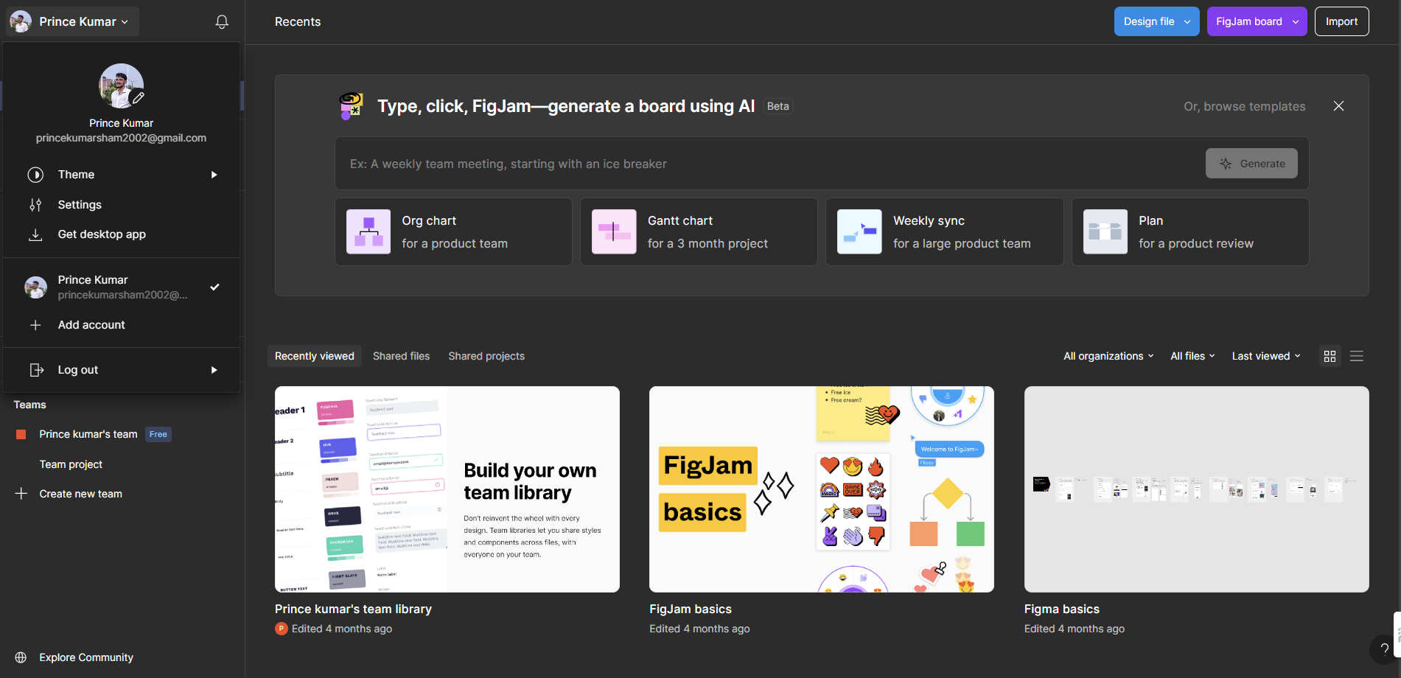

QUORA 2

PROFILE AND ACCOMPLISHMENT:

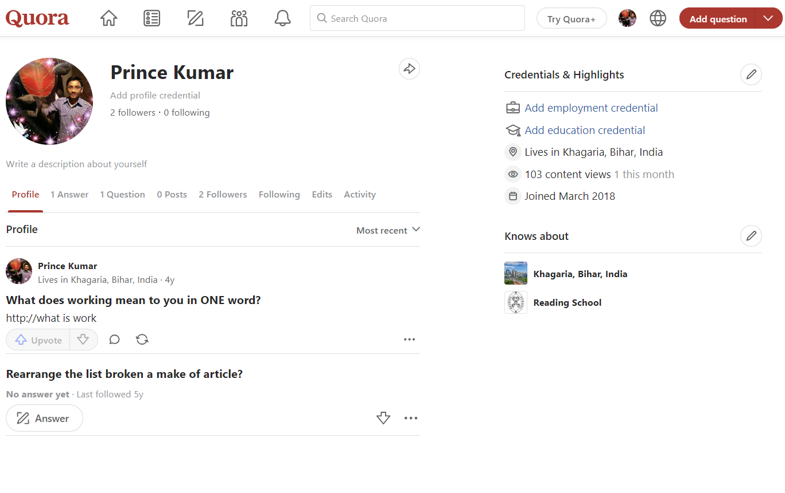

STACKOVERFLOW 3

PROFILE:

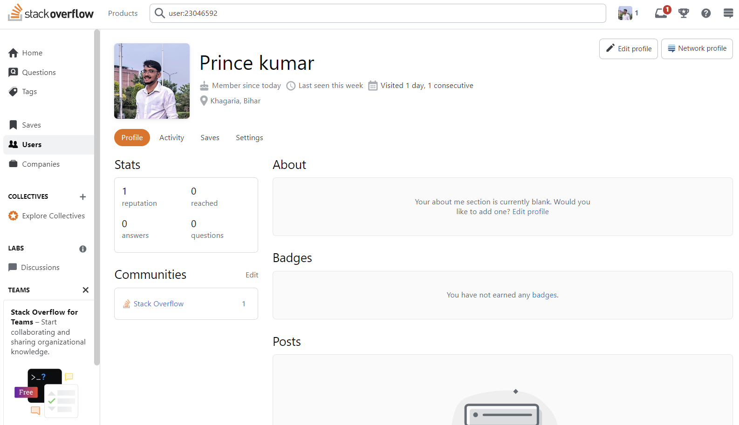

**HACKER RANK 4**

**Profile:**

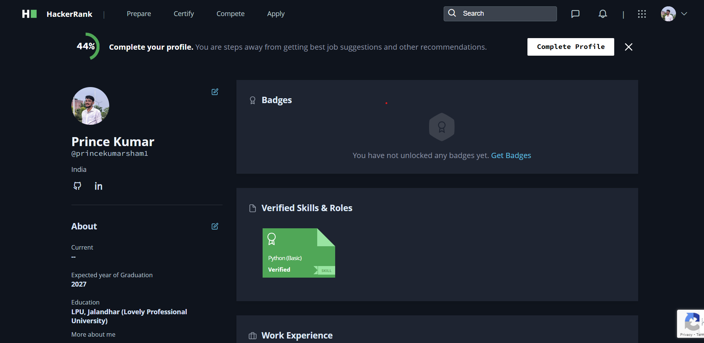

**HACKER EARTH 5**

**Profile:**

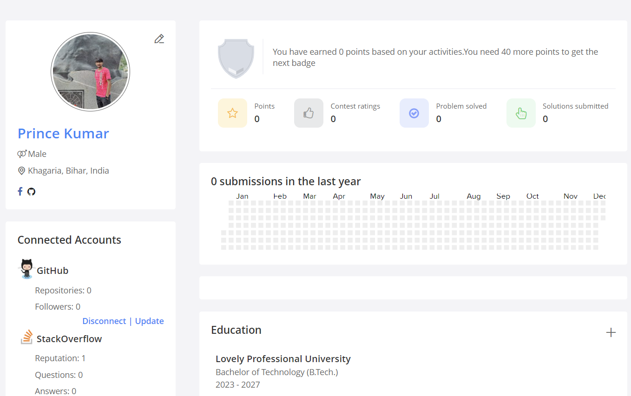

**GEEKS FOR GEEKS 6**

**Profile:**

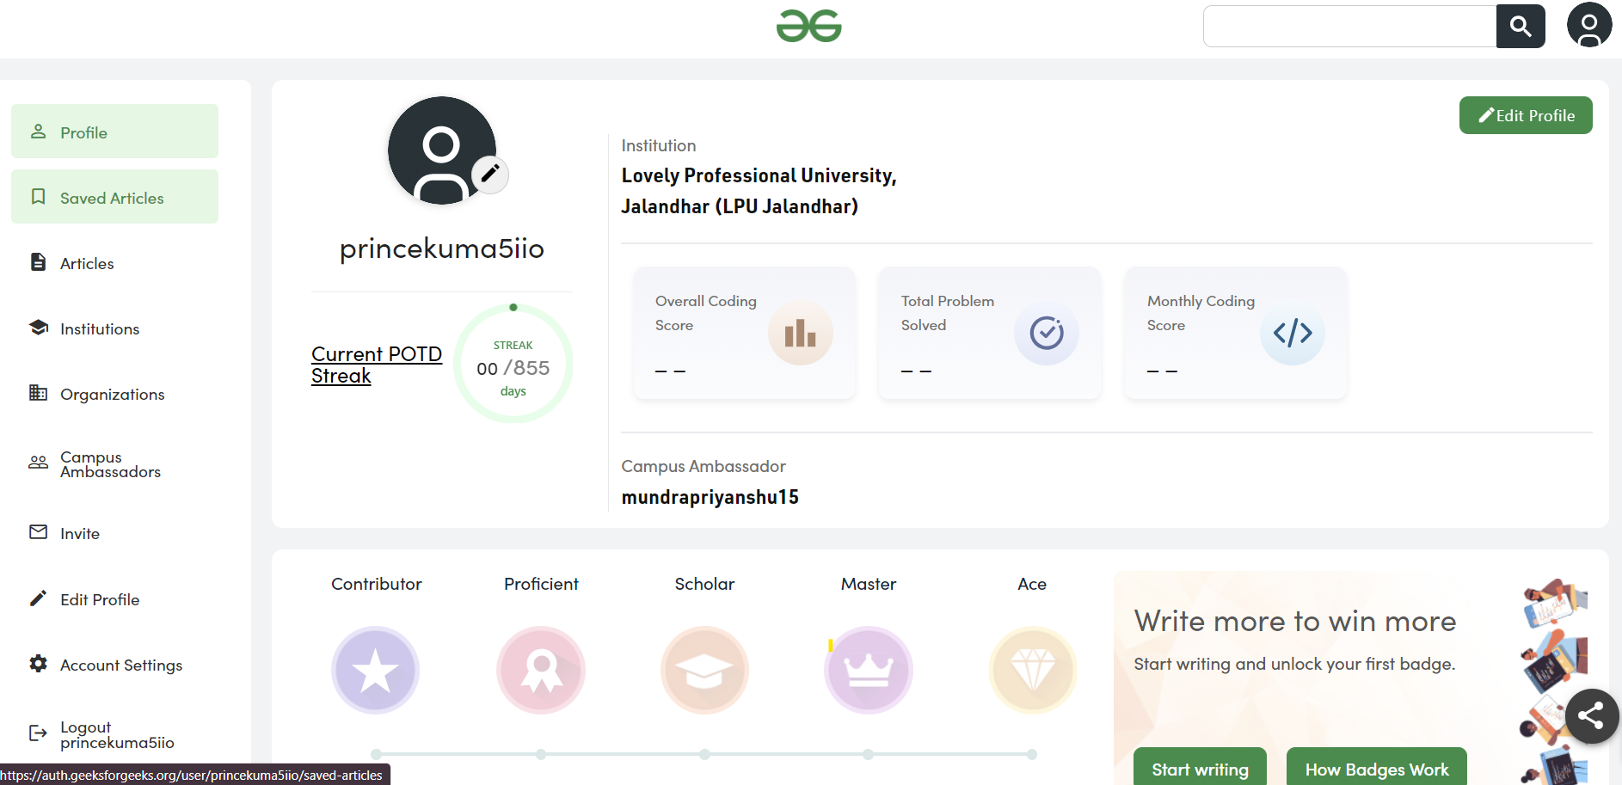

**GITHUB 7**

**Profile:**

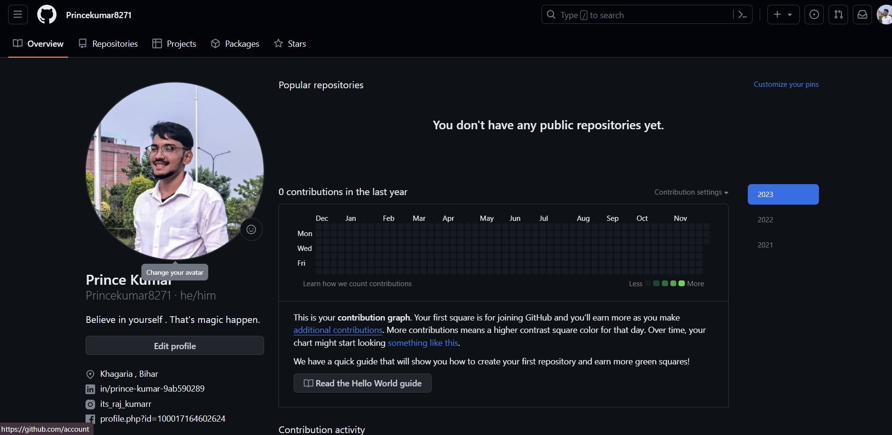

**GIT 8**

**Accomplishment:**

**Created a repository and commited a file a in it .**

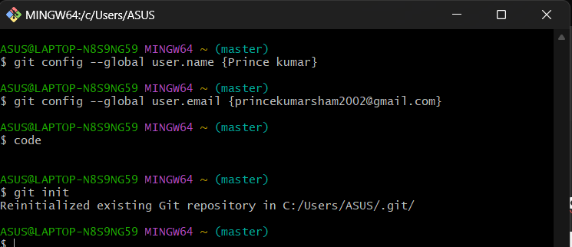

**CV 9**

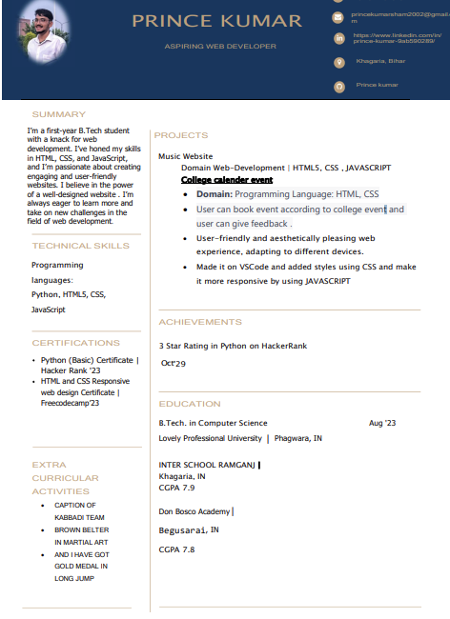

**MOOCS 10**

